
Summative Project
ADDB7311

November 7, 2024
ST10393280
Daniel Luke James

Table of Contents
Question 1: 2
Question 2: 12
12
Question 3: 13
13
Question 4: 14
14
Question 5: 15
Question 6: 17
17
Question 7: 18
18
Question 8: 19
Question 9: 20
Question 10: 22
SQL CODE: 26
Reference List 62

Question 1: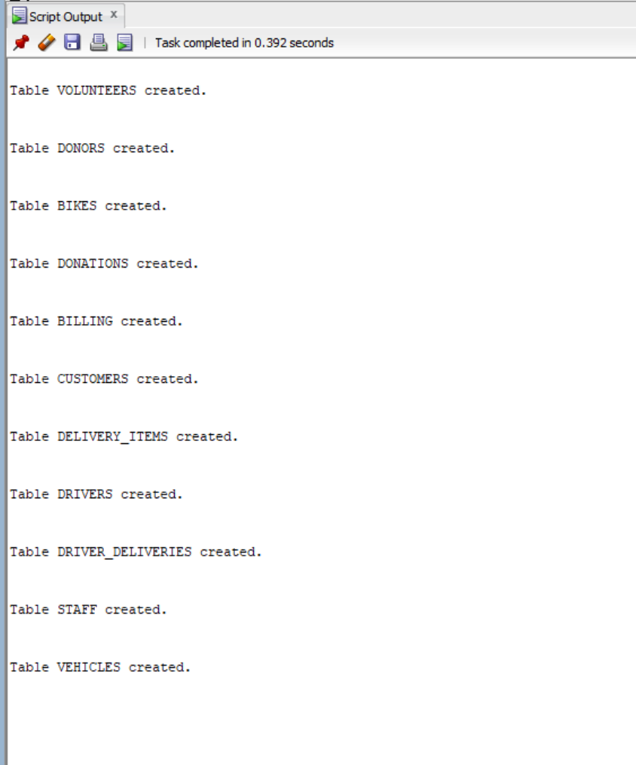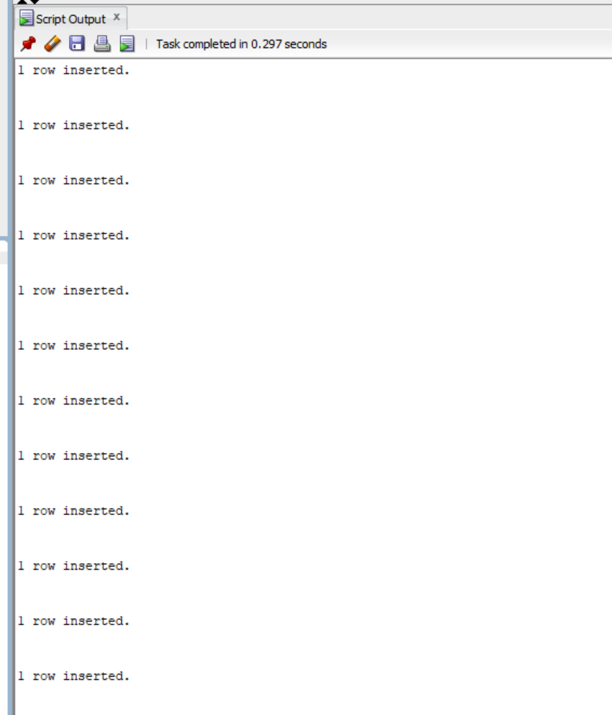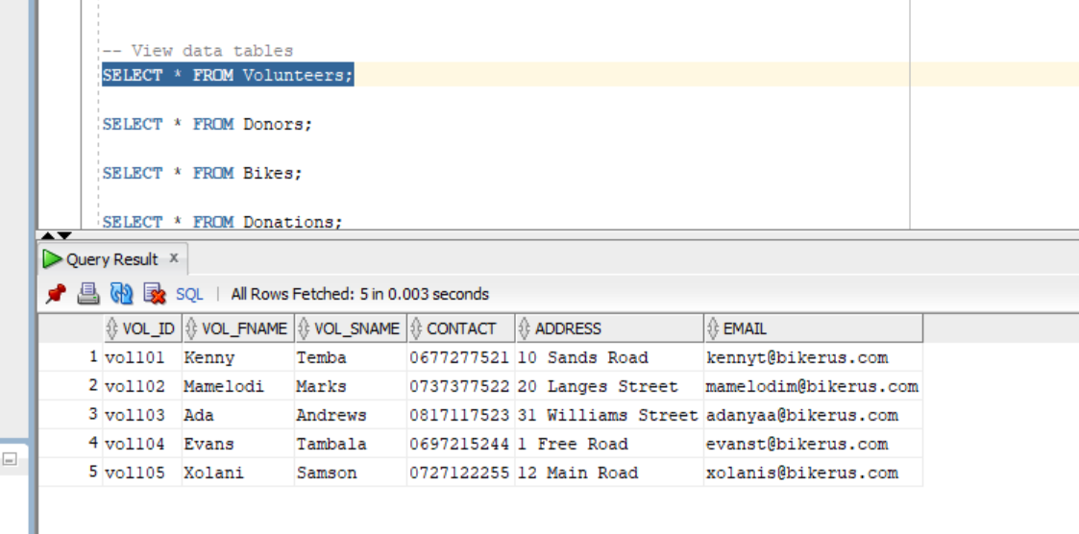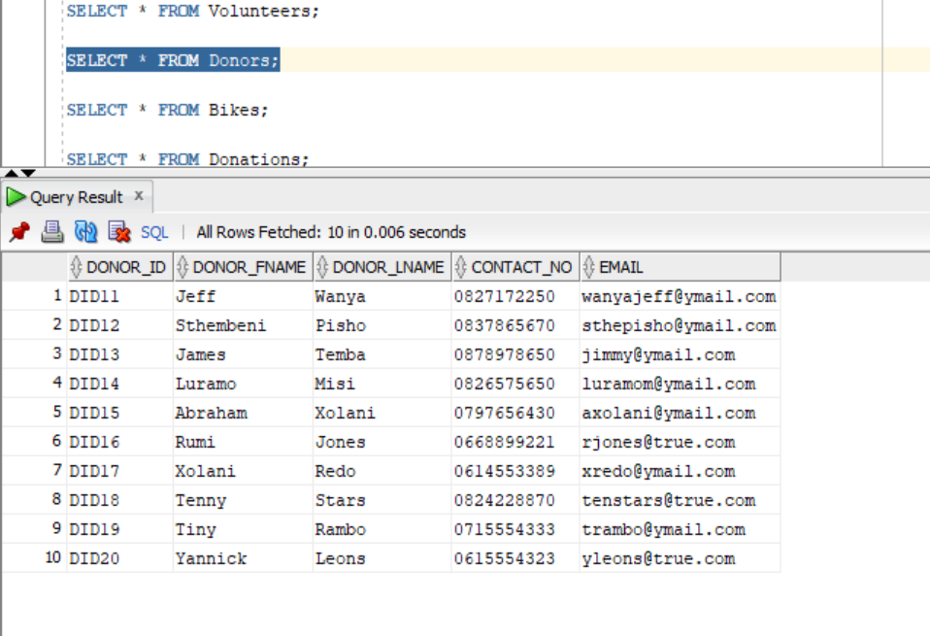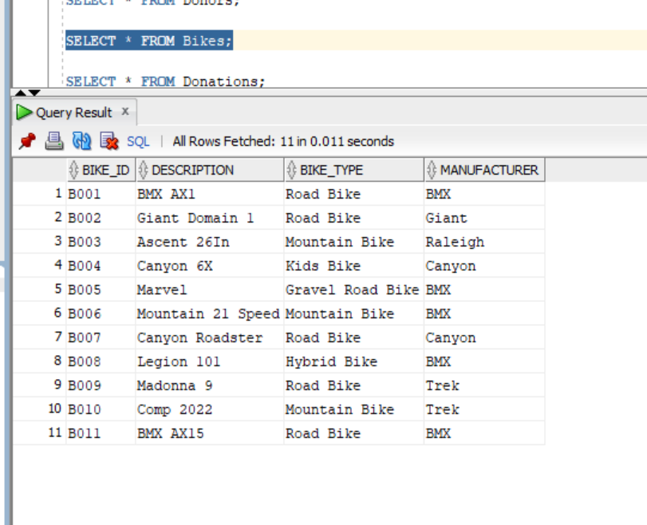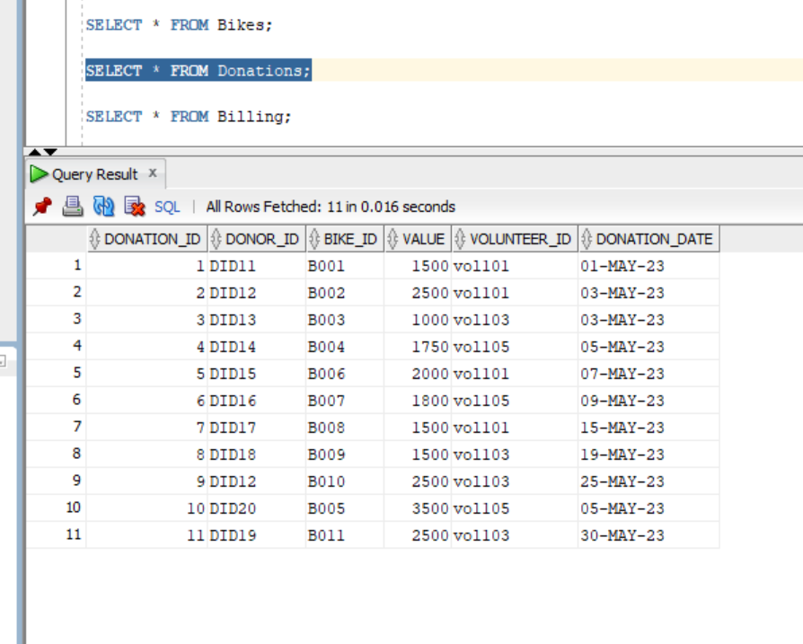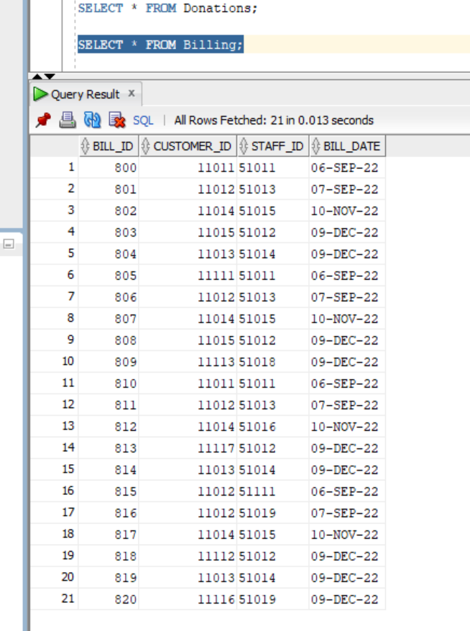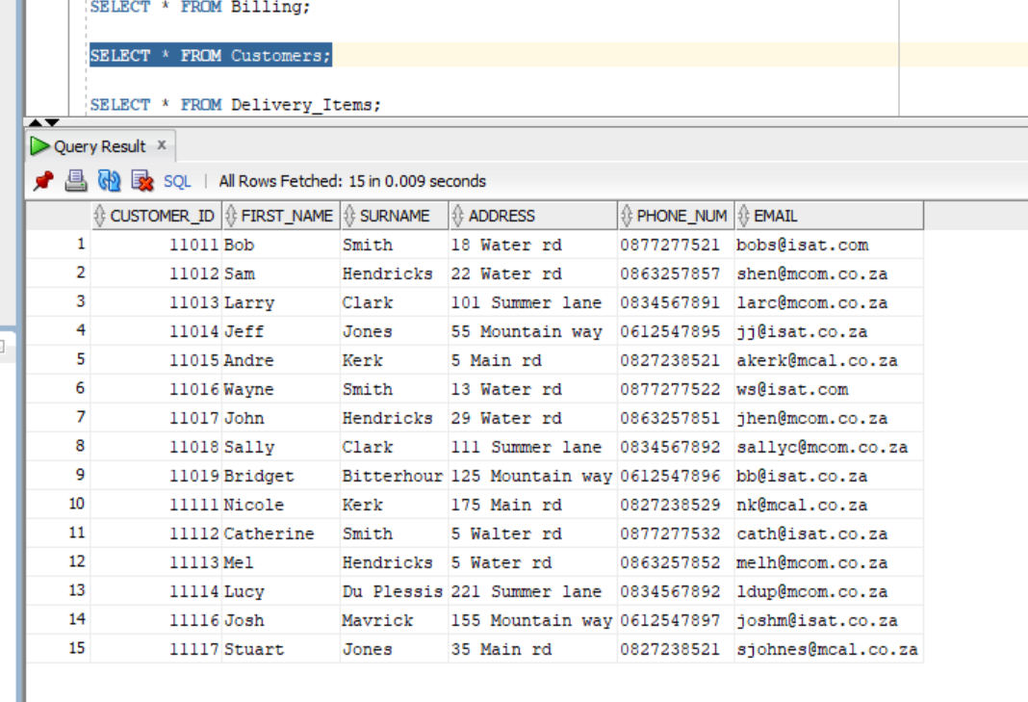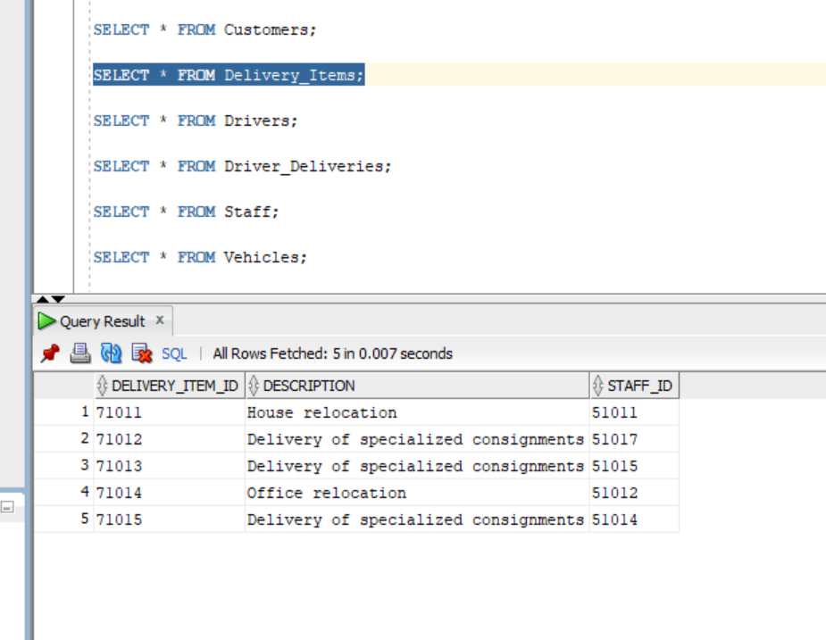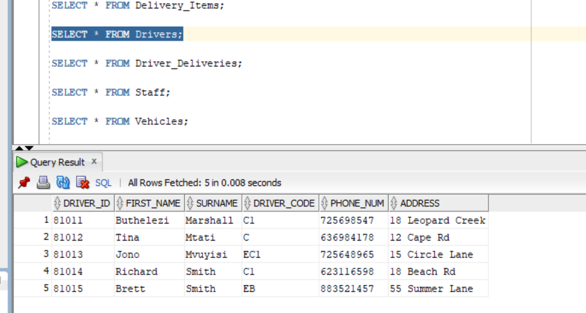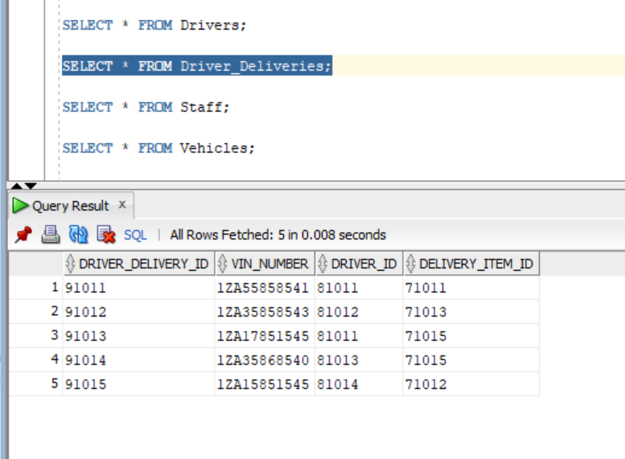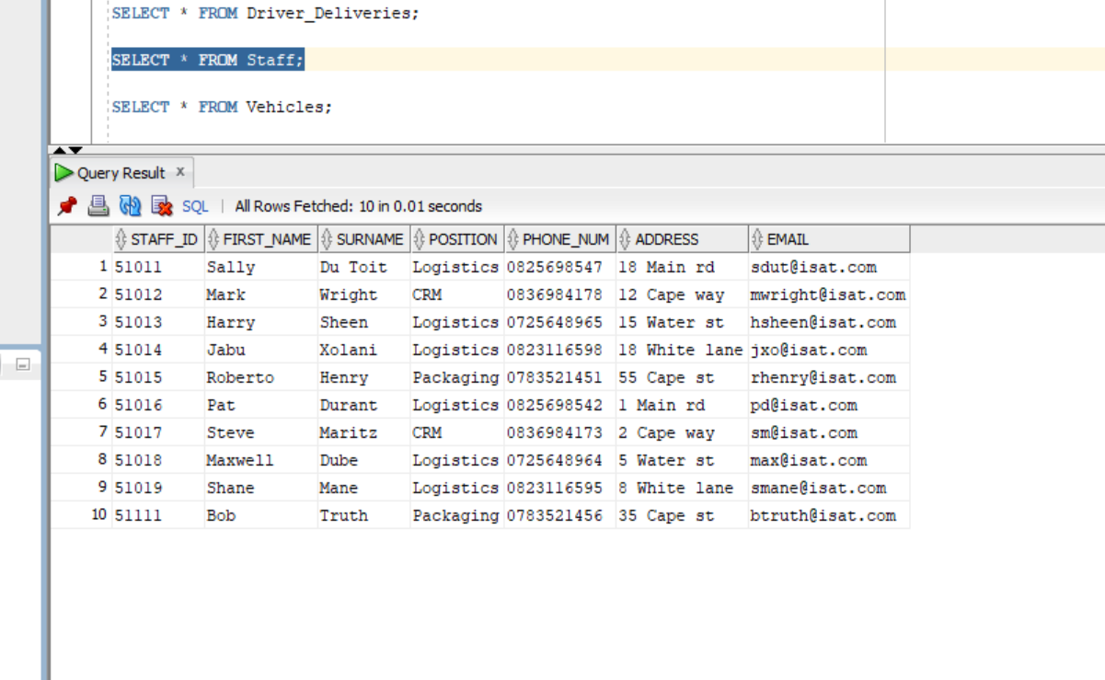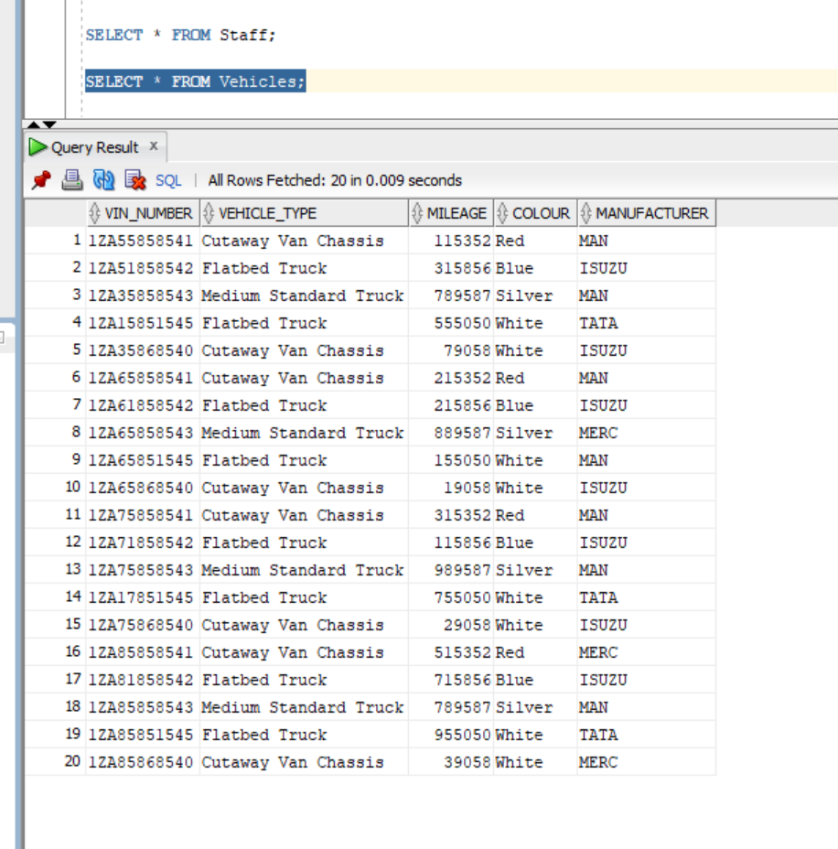

Question 2:

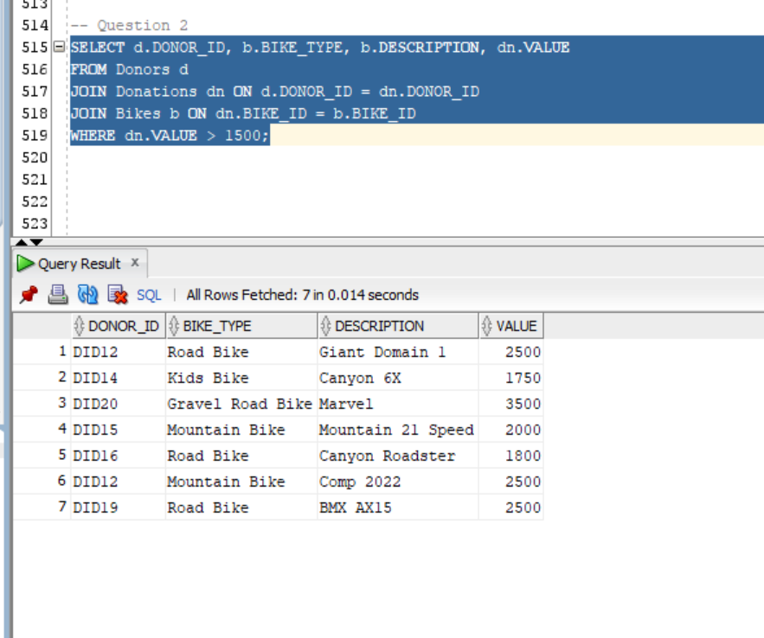
(IIE, 2024).

Question 3:

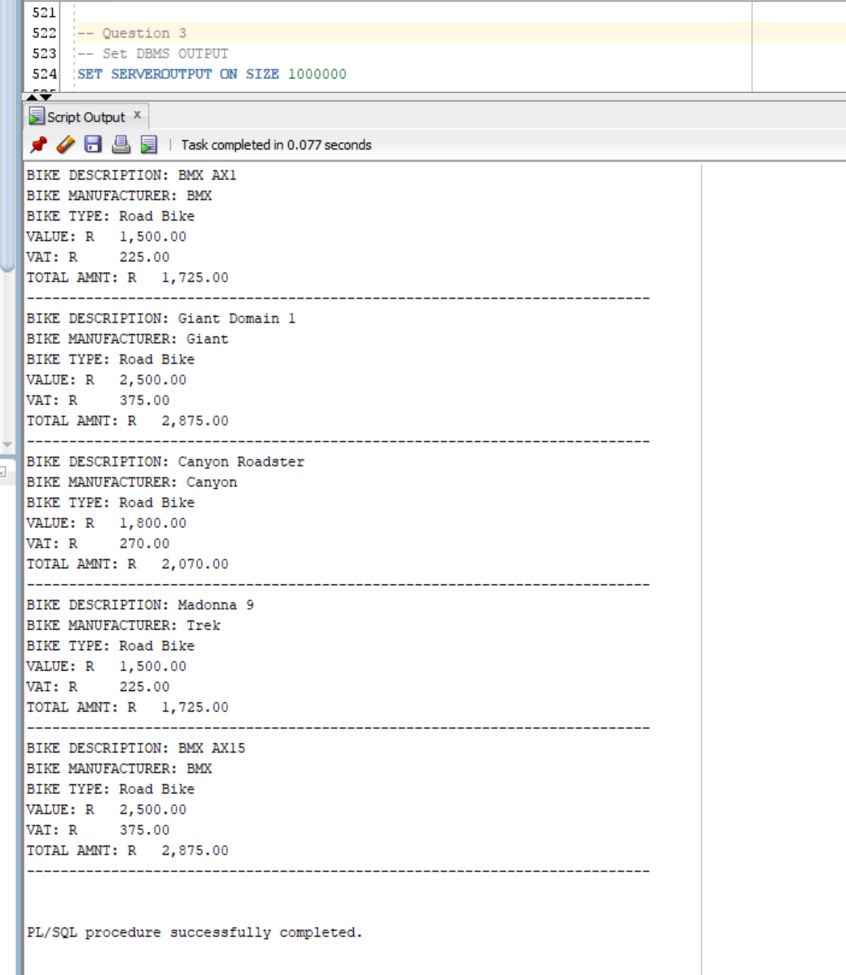
(IIE, 2024).

Question 4:

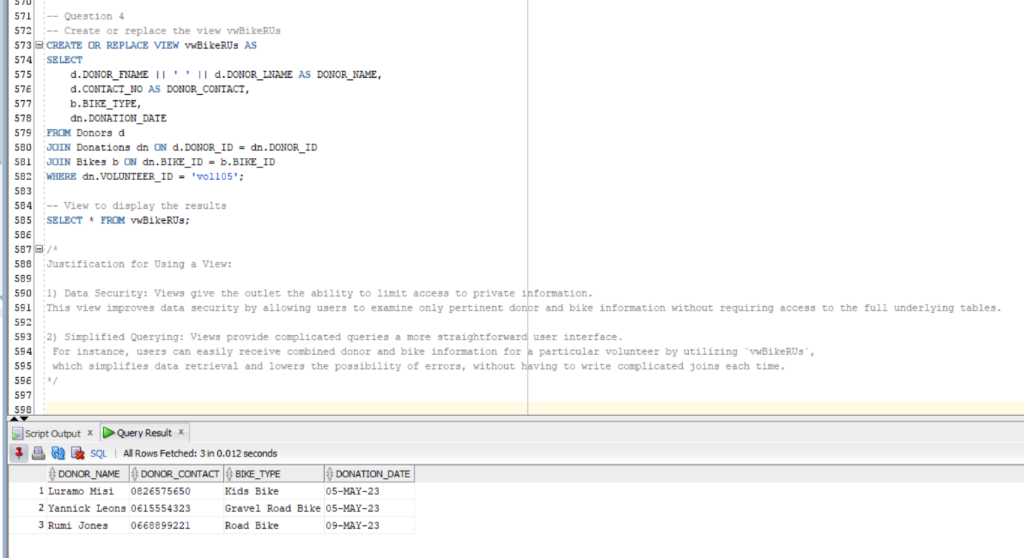
(IIE, 2024).

Question 5: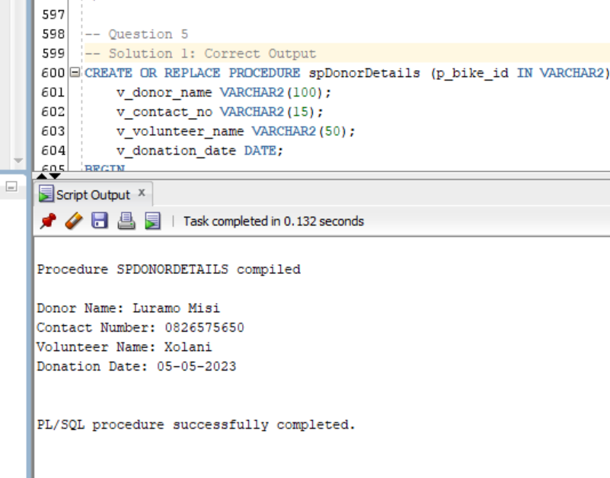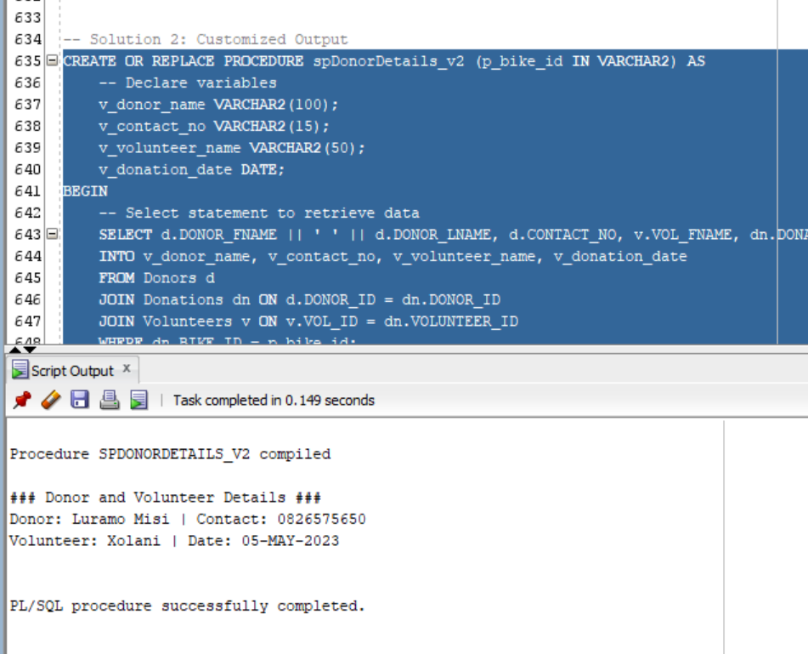
(IIE, 2024).

Question 6:

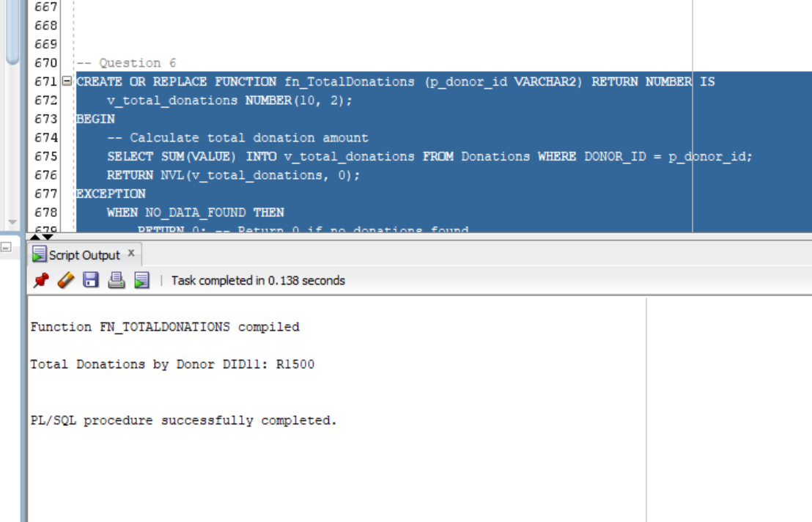
(IIE, 2024).

Question 7:

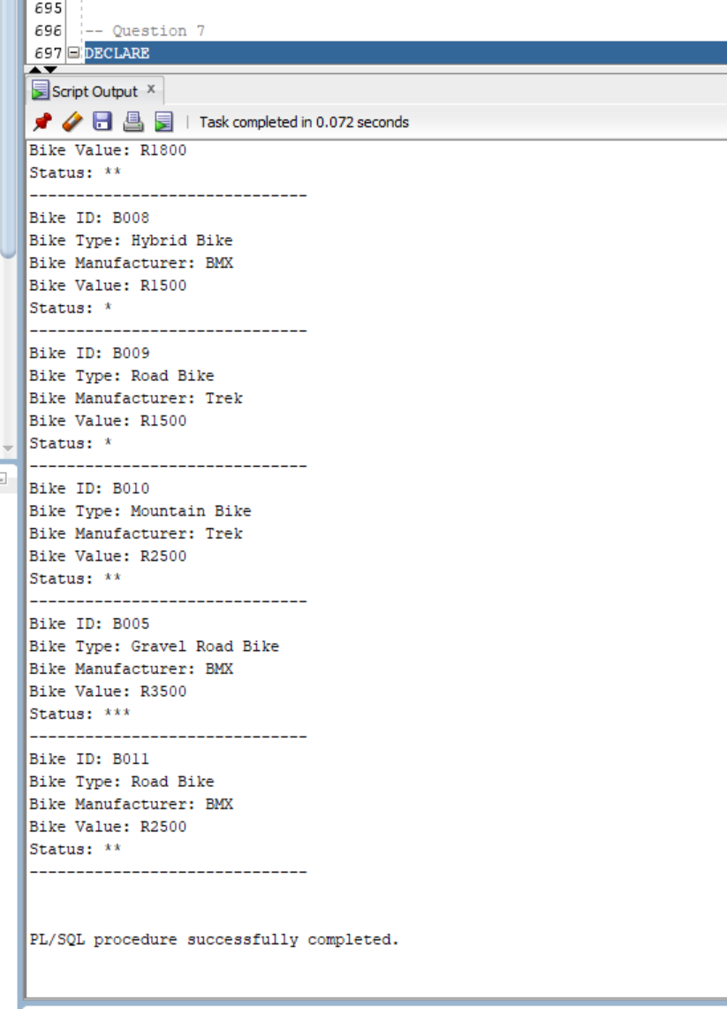
(IIE, 2024).

Question 8:
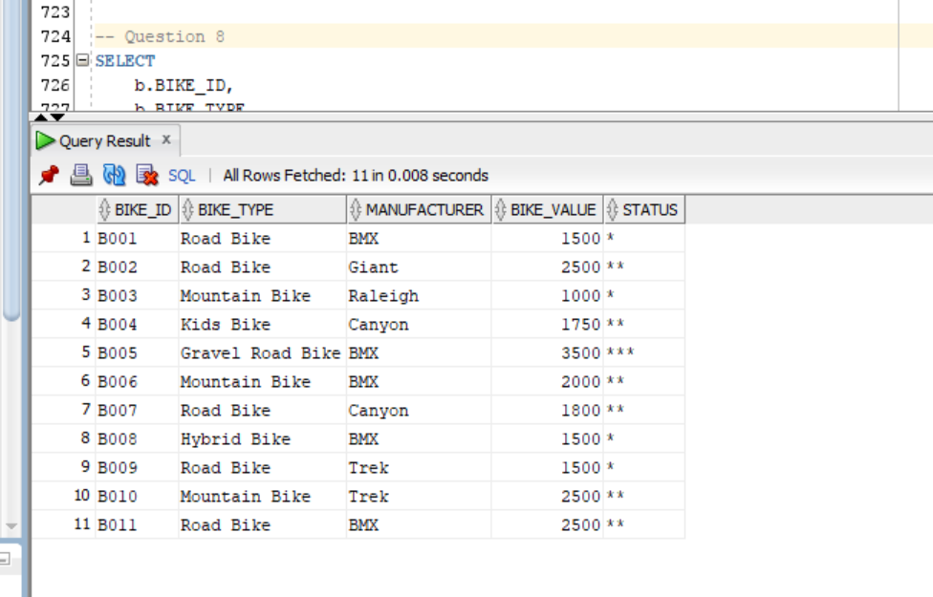

Question 9: 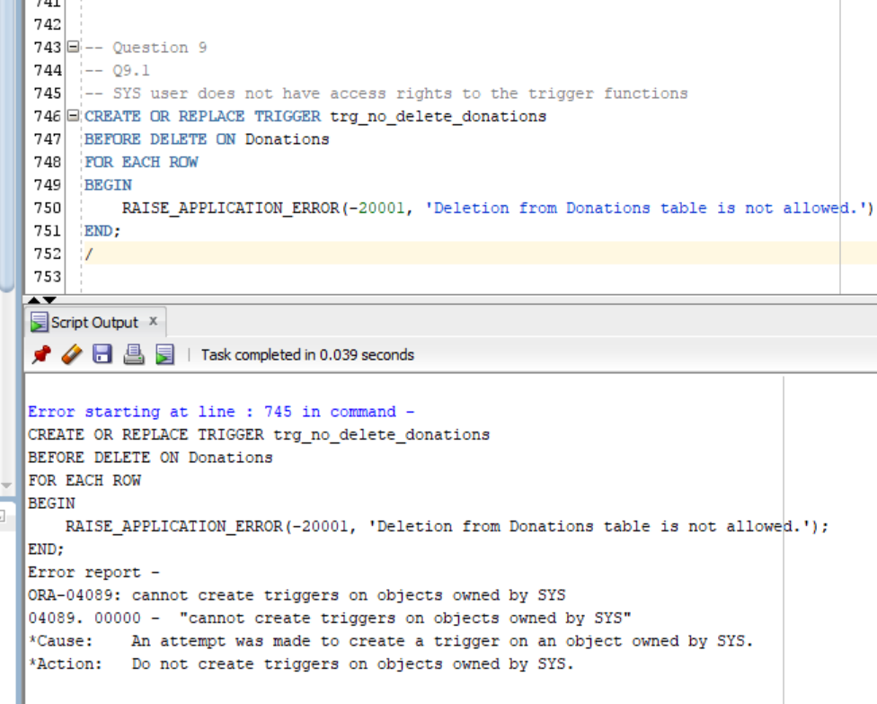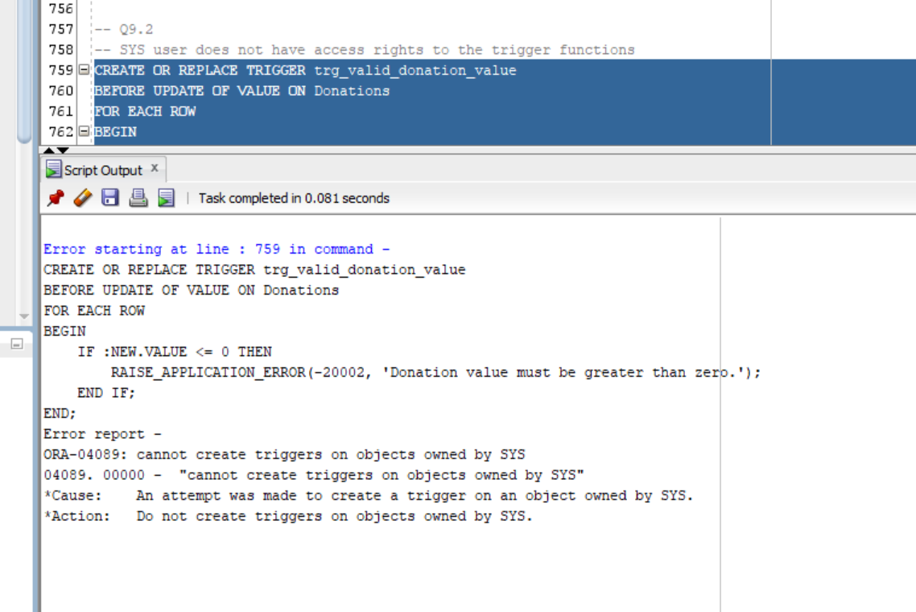
(IIE, 2024).

Question 10:
Technical Report on Maintaining BikesRUs' Availability, Integrity, and Confidentiality.
Ensuring the security, accuracy, and consistency of data is crucial when establishing a database system for BikesRUs. A framework for accomplishing this is provided by the ideas of Confidentiality, Integrity, and Availability (CIA). A thorough explanation of how to apply these ideas at BikesRUs, complete with relevant resources, methods, and examples, is provided below (dev, 2021).

1. Confidentiality
Confidentiality guards against unwanted access and guarantees that only authorized personnel can access sensitive data. Donor information, volunteer information, and transaction records are examples of sensitive data for BikesRUs. Here are some ways to protect confidentiality (rubrik, 2024).
Role-based access and access control restricts data access according to a user's role, access control mechanisms ought to be put in place. Sales volunteers, for instance, might only require access to data pertaining to customers, whereas donation handlers ought to have access to donor and donation records. By putting role-based access control (RBAC) into practice, you can make sure that each user group can access only the information required for their role. This can be set up in SQL by assigning particular table access according to user roles using GRANT statements (rubrik, 2024).
Code Example:
GRANT SELECT ON Donations TO Sales_Volunteer;
GRANT SELECT, INSERT ON Donations TO Donation_Manager;

With data encryption maintaining confidentiality requires encrypting sensitive data both in transit (such as over a network) and at rest (such as in a database). Databases such as Oracle and SQL Server support Transparent Data Encryption (TDE), which encrypts stored data without requiring modifications to the application. For example, the Donors table's sensitive fields, such as addresses or phone numbers, can be encrypted to lower the possibility of unintentional access to the data in the database.

Views for data concealing are for users who need restricted data visibility, views can assist in limiting and masking data. To ensure confidentiality for the Donor table data, a view could by showing donor names and bike types while concealing contact information.
Code Example:
CREATE VIEW vwLimitedDonorInfo AS
SELECT DONOR_ID, DONOR_FNAME, DONOR_LNAME, BIKE_TYPE
FROM Donors
JOIN Bikes ON Donors.DONOR_ID = Bikes.DONOR_ID;

2. Integrity
Throughout the database lifecycle, data integrity guarantees that the information is reliable, precise, and trustworthy. Ensuring the accuracy of bike data, volunteer information, and donation records is crucial for BikesRUs (dev, 2021). The techniques to preserve data integrity are listed below.

Foreign keys, unique constraints, and primary keys are examples of constraints. To ensure data consistency, use constraints. While foreign keys preserve relationships between tables, primary keys guarantee that every entry in a table is unique. Setting foreign keys stops donation entries for non-existent donors or bikes because the Donations table refers to the Donors and Bikes tables.
Code Example:
ALTER TABLE Donations
ADD CONSTRAINT FK_DonorID FOREIGN KEY (DONOR_ID) REFERENCES Donors(DONOR_ID);
Data validation Triggers have the ability to enforce intricate integrity regulations. A trigger, for example, can guarantee that bike values in the Donations table are greater than zero, thereby avoiding inaccurate data entry. Since BikesRUs must keep a comprehensive record of all donations, another trigger might stop donation records from being deleted.
Code Example:
CREATE TRIGGER PreventNegativeBikeValue
BEFORE INSERT OR UPDATE ON Donations
FOR EACH ROW
WHEN (NEW.VALUE <= 0)
BEGIN
RAISE_APPLICATION_ERROR(-20001, 'Bike value must be positive.');
END;
Frequent data Inspection and verifying: Discrepancies or anomalies can be found with the aid of periodic data audits. Inconsistencies can be found and fixed, for instance, by routinely checking the Donations and Bikes tables. By spotting duplicate records, NULL values in required fields, or inconsistent relationships, SQL scripts or automated tools can help with auditing (dev, 2021).

3. Accessibility
Availability guarantees that authorized users can access the database at any time. A strong availability strategy is essential because BikesRUs depends on its database to track inventory, manage donations, and record transactions (dev, 2021).
Regular backups are your initial line of protection for data availability, and backup and recovery can help. Periodically, you should make full backups and incremental backups of any changes you make in between. These backups allow for quick restoration in the event of data loss. To guarantee data recovery functionality, computerized backups should be intended and backup restoration tested on a regular basis (rubrik, 2024).
Consider a high-performance setup that includes clustering and database replication for continuous operation. In order to provide an alternative mechanism in the event that the primary server fails, replication entails copying data in real time to a different server. To improve availability, like SQL Server continually on the accessibility teams can spread data across several nodes (rubrik, 2024).
planning for disaster recovery, to specify how to resume operations in the event of a catastrophic event, such as a server crash or a natural disaster, BikesRUs should create a disaster recovery plan. A geographically remote backup location in which data is frequently replicated may be part of this plan.
The optimization of performance and database maintenance affects availability because sluggish query times can cause access issues. The server load can be decreased and query speed increased by using strategies like indexing fields that are frequently queried, such as bike IDs and donation dates (rubrik, 2024). Database optimization is maintained through routine maintenance tasks like updating database statistics and rebuilding indexes (dev, 2021).

Tools and Platform Examples:
SQL Server or Data Guard by Oracle Teams that are always available as these high-availability tools are intended to recover and replicate data in the event of a server failure. They enable the main and backup servers to synchronize in almost real-time.
Cloud-based database services like AWS RDS and Azure SQL Database come with built-in tools for high availability, scalability, and backup. Since both platforms offer computerized backup, the use of encryption, and adherence features, BikesRUs may want to use them if they intend to migrate to the cloud (rubrik, 2024).

SQL CODE:
-- ST10393280 Daniel Luke James

-- Question 1
-- New database schema
CREATE DATABASE BikesRUs;
USE BikesRUs;

-- Table Creation: Volunteers
CREATE TABLE Volunteers (
VOL_ID VARCHAR(10) PRIMARY KEY,
VOL_FNAME VARCHAR(50),
VOL_SNAME VARCHAR(50),
CONTACT VARCHAR(15),
ADDRESS VARCHAR(100),
EMAIL VARCHAR(50)
);

-- Table Creation: Donors
CREATE TABLE Donors (
DONOR_ID VARCHAR(10) PRIMARY KEY,
DONOR_FNAME VARCHAR(50),
DONOR_LNAME VARCHAR(50),
CONTACT_NO VARCHAR(15),
EMAIL VARCHAR(50)
);

-- Table Creation: Bikes
CREATE TABLE Bikes (
BIKE_ID VARCHAR(10) PRIMARY KEY,
DESCRIPTION VARCHAR(100),
BIKE_TYPE VARCHAR(20),
MANUFACTURER VARCHAR(50)
);

-- Table Creation: Donations
CREATE TABLE Donations (
DONATION_ID INT PRIMARY KEY,
DONOR_ID VARCHAR(10),
BIKE_ID VARCHAR(10),
VALUE DECIMAL(10,2),
VOLUNTEER_ID VARCHAR(10),
DONATION_DATE DATE,
FOREIGN KEY (DONOR_ID) REFERENCES Donors(DONOR_ID),
FOREIGN KEY (BIKE_ID) REFERENCES Bikes(BIKE_ID),
FOREIGN KEY (VOLUNTEER_ID) REFERENCES Volunteers(VOL_ID)
);

-- Table Creation: Billing
CREATE TABLE Billing (
BILL_ID INT PRIMARY KEY,
CUSTOMER_ID INT,
STAFF_ID VARCHAR(10),
BILL_DATE DATE
);

-- Table Creation: Customers
CREATE TABLE Customers (
CUSTOMER_ID INT PRIMARY KEY,
FIRST_NAME VARCHAR(50),
SURNAME VARCHAR(50),
ADDRESS VARCHAR(100),
PHONE_NUM VARCHAR(15),
EMAIL VARCHAR(50)
);

-- Table Creation: Delivery Items
CREATE TABLE Delivery_Items (
DELIVERY_ITEM_ID VARCHAR(10) PRIMARY KEY,
DESCRIPTION VARCHAR(100),
STAFF_ID VARCHAR(10)
);

-- Table Creation: Drivers
CREATE TABLE Drivers (
DRIVER_ID VARCHAR(10) PRIMARY KEY,
FIRST_NAME VARCHAR(50),
SURNAME VARCHAR(50),
DRIVER_CODE VARCHAR(10),
PHONE_NUM VARCHAR(15),
ADDRESS VARCHAR(100)
);

-- Table Creation: Driver Deliveries
CREATE TABLE Driver_Deliveries (
DRIVER_DELIVERY_ID VARCHAR(10) PRIMARY KEY,
VIN_NUMBER VARCHAR(20),
DRIVER_ID VARCHAR(10),
DELIVERY_ITEM_ID VARCHAR(10),
FOREIGN KEY (DRIVER_ID) REFERENCES Drivers(DRIVER_ID),
FOREIGN KEY (DELIVERY_ITEM_ID) REFERENCES Delivery_Items(DELIVERY_ITEM_ID)
);

-- Table Creation: Staff
CREATE TABLE Staff (
STAFF_ID VARCHAR(10) PRIMARY KEY,
FIRST_NAME VARCHAR(50),
SURNAME VARCHAR(50),
POSITION VARCHAR(50),
PHONE_NUM VARCHAR(15),
ADDRESS VARCHAR(100),
EMAIL VARCHAR(50)
);

-- Table Creation: Vehicles
CREATE TABLE Vehicles (
VIN_NUMBER VARCHAR(20) PRIMARY KEY,
VEHICLE_TYPE VARCHAR(50),
MILEAGE INT,
COLOUR VARCHAR(20),
MANUFACTURER VARCHAR(50)
);

-- Insert Data for Volunteers
INSERT INTO Volunteers (VOL_ID, VOL_FNAME, VOL_SNAME, CONTACT, ADDRESS, EMAIL) VALUES
('vol101', 'Kenny', 'Temba', '0677277521', '10 Sands Road', 'kennyt@bikerus.com');

INSERT INTO Volunteers (VOL_ID, VOL_FNAME, VOL_SNAME, CONTACT, ADDRESS, EMAIL) VALUES
('vol102', 'Mamelodi', 'Marks', '0737377522', '20 Langes Street', 'mamelodim@bikerus.com');

INSERT INTO Volunteers (VOL_ID, VOL_FNAME, VOL_SNAME, CONTACT, ADDRESS, EMAIL) VALUES
('vol103', 'Ada', 'Andrews', '0817117523', '31 Williams Street', 'adanyaa@bikerus.com');

INSERT INTO Volunteers (VOL_ID, VOL_FNAME, VOL_SNAME, CONTACT, ADDRESS, EMAIL) VALUES
('vol104', 'Evans', 'Tambala', '0697215244', '1 Free Road', 'evanst@bikerus.com');

INSERT INTO Volunteers (VOL_ID, VOL_FNAME, VOL_SNAME, CONTACT, ADDRESS, EMAIL) VALUES
('vol105', 'Xolani', 'Samson', '0727122255', '12 Main Road', 'xolanis@bikerus.com');

-- Insert Data for Donors
INSERT INTO Donors (DONOR_ID, DONOR_FNAME, DONOR_LNAME, CONTACT_NO, EMAIL) VALUES
('DID11', 'Jeff', 'Wanya', '0827172250', 'wanyajeff@ymail.com');

INSERT INTO Donors (DONOR_ID, DONOR_FNAME, DONOR_LNAME, CONTACT_NO, EMAIL) VALUES
('DID12', 'Sthembeni', 'Pisho', '0837865670', 'sthepisho@ymail.com');

INSERT INTO Donors (DONOR_ID, DONOR_FNAME, DONOR_LNAME, CONTACT_NO, EMAIL) VALUES
('DID13', 'James', 'Temba', '0878978650', 'jimmy@ymail.com');

INSERT INTO Donors (DONOR_ID, DONOR_FNAME, DONOR_LNAME, CONTACT_NO, EMAIL) VALUES
('DID14', 'Luramo', 'Misi', '0826575650', 'luramom@ymail.com');

INSERT INTO Donors (DONOR_ID, DONOR_FNAME, DONOR_LNAME, CONTACT_NO, EMAIL) VALUES
('DID15', 'Abraham', 'Xolani', '0797656430', 'axolani@ymail.com');

INSERT INTO Donors (DONOR_ID, DONOR_FNAME, DONOR_LNAME, CONTACT_NO, EMAIL) VALUES
('DID16', 'Rumi', 'Jones', '0668899221', 'rjones@true.com');

INSERT INTO Donors (DONOR_ID, DONOR_FNAME, DONOR_LNAME, CONTACT_NO, EMAIL) VALUES
('DID17', 'Xolani', 'Redo', '0614553389', 'xredo@ymail.com');

INSERT INTO Donors (DONOR_ID, DONOR_FNAME, DONOR_LNAME, CONTACT_NO, EMAIL) VALUES
('DID18', 'Tenny', 'Stars', '0824228870', 'tenstars@true.com');

INSERT INTO Donors (DONOR_ID, DONOR_FNAME, DONOR_LNAME, CONTACT_NO, EMAIL) VALUES
('DID19', 'Tiny', 'Rambo', '0715554333', 'trambo@ymail.com');

INSERT INTO Donors (DONOR_ID, DONOR_FNAME, DONOR_LNAME, CONTACT_NO, EMAIL) VALUES
('DID20', 'Yannick', 'Leons', '0615554323', 'yleons@true.com');

-- Insert Data for Bikes
INSERT INTO Bikes (BIKE_ID, DESCRIPTION, BIKE_TYPE, MANUFACTURER) VALUES
('B001', 'BMX AX1', 'Road Bike', 'BMX');

INSERT INTO Bikes (BIKE_ID, DESCRIPTION, BIKE_TYPE, MANUFACTURER) VALUES
('B002', 'Giant Domain 1', 'Road Bike', 'Giant');

INSERT INTO Bikes (BIKE_ID, DESCRIPTION, BIKE_TYPE, MANUFACTURER) VALUES
('B003', 'Ascent 26In', 'Mountain Bike', 'Raleigh');

INSERT INTO Bikes (BIKE_ID, DESCRIPTION, BIKE_TYPE, MANUFACTURER) VALUES
('B004', 'Canyon 6X', 'Kids Bike', 'Canyon');

INSERT INTO Bikes (BIKE_ID, DESCRIPTION, BIKE_TYPE, MANUFACTURER) VALUES
('B005', 'Marvel', 'Gravel Road Bike', 'BMX');

INSERT INTO Bikes (BIKE_ID, DESCRIPTION, BIKE_TYPE, MANUFACTURER) VALUES
('B006', 'Mountain 21 Speed', 'Mountain Bike', 'BMX');

INSERT INTO Bikes (BIKE_ID, DESCRIPTION, BIKE_TYPE, MANUFACTURER) VALUES
('B007', 'Canyon Roadster', 'Road Bike', 'Canyon');

INSERT INTO Bikes (BIKE_ID, DESCRIPTION, BIKE_TYPE, MANUFACTURER) VALUES
('B008', 'Legion 101', 'Hybrid Bike', 'BMX');

INSERT INTO Bikes (BIKE_ID, DESCRIPTION, BIKE_TYPE, MANUFACTURER) VALUES
('B009', 'Madonna 9', 'Road Bike', 'Trek');

INSERT INTO Bikes (BIKE_ID, DESCRIPTION, BIKE_TYPE, MANUFACTURER) VALUES
('B010', 'Comp 2022', 'Mountain Bike', 'Trek');

INSERT INTO Bikes (BIKE_ID, DESCRIPTION, BIKE_TYPE, MANUFACTURER) VALUES
('B011', 'BMX AX15', 'Road Bike', 'BMX');

-- Insert Data for Donations
INSERT INTO Donations (DONATION_ID, DONOR_ID, BIKE_ID, VALUE, VOLUNTEER_ID, DONATION_DATE) VALUES
(1, 'DID11', 'B001', 1500, 'vol101', TO_DATE('01-05-23', 'DD-MM-YY'));

INSERT INTO Donations (DONATION_ID, DONOR_ID, BIKE_ID, VALUE, VOLUNTEER_ID, DONATION_DATE) VALUES
(2, 'DID12', 'B002', 2500, 'vol101', TO_DATE('03-05-23', 'DD-MM-YY'));

INSERT INTO Donations (DONATION_ID, DONOR_ID, BIKE_ID, VALUE, VOLUNTEER_ID, DONATION_DATE) VALUES
(3, 'DID13', 'B003', 1000, 'vol103', TO_DATE('03-05-23', 'DD-MM-YY'));

INSERT INTO Donations (DONATION_ID, DONOR_ID, BIKE_ID, VALUE, VOLUNTEER_ID, DONATION_DATE) VALUES
(4, 'DID14', 'B004', 1750, 'vol105', TO_DATE('05-05-23', 'DD-MM-YY'));

INSERT INTO Donations (DONATION_ID, DONOR_ID, BIKE_ID, VALUE, VOLUNTEER_ID, DONATION_DATE) VALUES
(5, 'DID15', 'B006', 2000, 'vol101', TO_DATE('07-05-23', 'DD-MM-YY'));

INSERT INTO Donations (DONATION_ID, DONOR_ID, BIKE_ID, VALUE, VOLUNTEER_ID, DONATION_DATE) VALUES
(6, 'DID16', 'B007', 1800, 'vol105', TO_DATE('09-05-23', 'DD-MM-YY'));

INSERT INTO Donations (DONATION_ID, DONOR_ID, BIKE_ID, VALUE, VOLUNTEER_ID, DONATION_DATE) VALUES
(7, 'DID17', 'B008', 1500, 'vol101', TO_DATE('15-05-23', 'DD-MM-YY'));

INSERT INTO Donations (DONATION_ID, DONOR_ID, BIKE_ID, VALUE, VOLUNTEER_ID, DONATION_DATE) VALUES
(8, 'DID18', 'B009', 1500, 'vol103', TO_DATE('19-05-23', 'DD-MM-YY'));

INSERT INTO Donations (DONATION_ID, DONOR_ID, BIKE_ID, VALUE, VOLUNTEER_ID, DONATION_DATE) VALUES
(9, 'DID12', 'B010', 2500, 'vol103', TO_DATE('25-05-23', 'DD-MM-YY'));

INSERT INTO Donations (DONATION_ID, DONOR_ID, BIKE_ID, VALUE, VOLUNTEER_ID, DONATION_DATE) VALUES
(10, 'DID20', 'B005', 3500, 'vol105', TO_DATE('05-05-23', 'DD-MM-YY'));

INSERT INTO Donations (DONATION_ID, DONOR_ID, BIKE_ID, VALUE, VOLUNTEER_ID, DONATION_DATE) VALUES
(11, 'DID19', 'B011', 2500, 'vol103', TO_DATE('30-05-23', 'DD-MM-YY'));

-- Insert Data for Billing
INSERT INTO Billing (BILL_ID, CUSTOMER_ID, STAFF_ID, BILL_DATE) VALUES
(800, 11011, '51011', TO_DATE('06-09-22', 'DD-MM-YY'));

INSERT INTO Billing (BILL_ID, CUSTOMER_ID, STAFF_ID, BILL_DATE) VALUES
(801, 11012, '51013', TO_DATE('07-09-22', 'DD-MM-YY'));

INSERT INTO Billing (BILL_ID, CUSTOMER_ID, STAFF_ID, BILL_DATE) VALUES
(802, 11014, '51015', TO_DATE('10-11-22', 'DD-MM-YY'));

INSERT INTO Billing (BILL_ID, CUSTOMER_ID, STAFF_ID, BILL_DATE) VALUES
(803, 11015, '51012', TO_DATE('09-12-22', 'DD-MM-YY'));

INSERT INTO Billing (BILL_ID, CUSTOMER_ID, STAFF_ID, BILL_DATE) VALUES
(804, 11013, '51014', TO_DATE('09-12-22', 'DD-MM-YY'));

INSERT INTO Billing (BILL_ID, CUSTOMER_ID, STAFF_ID, BILL_DATE) VALUES
(805, 11111, '51011', TO_DATE('06-09-22', 'DD-MM-YY'));

INSERT INTO Billing (BILL_ID, CUSTOMER_ID, STAFF_ID, BILL_DATE) VALUES
(806, 11012, '51013', TO_DATE('07-09-22', 'DD-MM-YY'));

INSERT INTO Billing (BILL_ID, CUSTOMER_ID, STAFF_ID, BILL_DATE) VALUES
(807, 11014, '51015', TO_DATE('10-11-22', 'DD-MM-YY'));

INSERT INTO Billing (BILL_ID, CUSTOMER_ID, STAFF_ID, BILL_DATE) VALUES
(808, 11015, '51012', TO_DATE('09-12-22', 'DD-MM-YY'));

INSERT INTO Billing (BILL_ID, CUSTOMER_ID, STAFF_ID, BILL_DATE) VALUES
(809, 11113, '51018', TO_DATE('09-12-22', 'DD-MM-YY'));

INSERT INTO Billing (BILL_ID, CUSTOMER_ID, STAFF_ID, BILL_DATE) VALUES
(810, 11011, '51011', TO_DATE('06-09-22', 'DD-MM-YY'));

INSERT INTO Billing (BILL_ID, CUSTOMER_ID, STAFF_ID, BILL_DATE) VALUES
(811, 11012, '51013', TO_DATE('07-09-22', 'DD-MM-YY'));

INSERT INTO Billing (BILL_ID, CUSTOMER_ID, STAFF_ID, BILL_DATE) VALUES
(812, 11014, '51016', TO_DATE('10-11-22', 'DD-MM-YY'));

INSERT INTO Billing (BILL_ID, CUSTOMER_ID, STAFF_ID, BILL_DATE) VALUES
(813, 11117, '51012', TO_DATE('09-12-22', 'DD-MM-YY'));

INSERT INTO Billing (BILL_ID, CUSTOMER_ID, STAFF_ID, BILL_DATE) VALUES
(814, 11013, '51014', TO_DATE('09-12-22', 'DD-MM-YY'));

INSERT INTO Billing (BILL_ID, CUSTOMER_ID, STAFF_ID, BILL_DATE) VALUES
(815, 11012, '51111', TO_DATE('06-09-22', 'DD-MM-YY'));

INSERT INTO Billing (BILL_ID, CUSTOMER_ID, STAFF_ID, BILL_DATE) VALUES
(816, 11012, '51019', TO_DATE('07-09-22', 'DD-MM-YY'));

INSERT INTO Billing (BILL_ID, CUSTOMER_ID, STAFF_ID, BILL_DATE) VALUES
(817, 11014, '51015', TO_DATE('10-11-22', 'DD-MM-YY'));

INSERT INTO Billing (BILL_ID, CUSTOMER_ID, STAFF_ID, BILL_DATE) VALUES
(818, 11112, '51012', TO_DATE('09-12-22', 'DD-MM-YY'));

INSERT INTO Billing (BILL_ID, CUSTOMER_ID, STAFF_ID, BILL_DATE) VALUES
(819, 11013, '51014', TO_DATE('09-12-22', 'DD-MM-YY'));

INSERT INTO Billing (BILL_ID, CUSTOMER_ID, STAFF_ID, BILL_DATE) VALUES
(820, 11116, '51019', TO_DATE('09-12-22', 'DD-MM-YY'));

-- Insert Data for Customers
INSERT INTO Customers (CUSTOMER_ID, FIRST_NAME, SURNAME, ADDRESS, PHONE_NUM, EMAIL) VALUES
(11011, 'Bob', 'Smith', '18 Water rd', '0877277521', 'bobs@isat.com');

INSERT INTO Customers (CUSTOMER_ID, FIRST_NAME, SURNAME, ADDRESS, PHONE_NUM, EMAIL) VALUES
(11012, 'Sam', 'Hendricks', '22 Water rd', '0863257857', 'shen@mcom.co.za');

INSERT INTO Customers (CUSTOMER_ID, FIRST_NAME, SURNAME, ADDRESS, PHONE_NUM, EMAIL) VALUES
(11013, 'Larry', 'Clark', '101 Summer lane', '0834567891', 'larc@mcom.co.za');

INSERT INTO Customers (CUSTOMER_ID, FIRST_NAME, SURNAME, ADDRESS, PHONE_NUM, EMAIL) VALUES
(11014, 'Jeff', 'Jones', '55 Mountain way', '0612547895', 'jj@isat.co.za');

INSERT INTO Customers (CUSTOMER_ID, FIRST_NAME, SURNAME, ADDRESS, PHONE_NUM, EMAIL) VALUES
(11015, 'Andre', 'Kerk', '5 Main rd', '0827238521', 'akerk@mcal.co.za');

INSERT INTO Customers (CUSTOMER_ID, FIRST_NAME, SURNAME, ADDRESS, PHONE_NUM, EMAIL) VALUES
(11016, 'Wayne', 'Smith', '13 Water rd', '0877277522', 'ws@isat.com');

INSERT INTO Customers (CUSTOMER_ID, FIRST_NAME, SURNAME, ADDRESS, PHONE_NUM, EMAIL) VALUES
(11017, 'John', 'Hendricks', '29 Water rd', '0863257851', 'jhen@mcom.co.za');

INSERT INTO Customers (CUSTOMER_ID, FIRST_NAME, SURNAME, ADDRESS, PHONE_NUM, EMAIL) VALUES
(11018, 'Sally', 'Clark', '111 Summer lane', '0834567892', 'sallyc@mcom.co.za');

INSERT INTO Customers (CUSTOMER_ID, FIRST_NAME, SURNAME, ADDRESS, PHONE_NUM, EMAIL) VALUES
(11019, 'Bridget', 'Bitterhour', '125 Mountain way', '0612547896', 'bb@isat.co.za');

INSERT INTO Customers (CUSTOMER_ID, FIRST_NAME, SURNAME, ADDRESS, PHONE_NUM, EMAIL) VALUES
(11111, 'Nicole', 'Kerk', '175 Main rd', '0827238529', 'nk@mcal.co.za');

INSERT INTO Customers (CUSTOMER_ID, FIRST_NAME, SURNAME, ADDRESS, PHONE_NUM, EMAIL) VALUES
(11112, 'Catherine', 'Smith', '5 Walter rd', '0877277532', 'cath@isat.co.za');

INSERT INTO Customers (CUSTOMER_ID, FIRST_NAME, SURNAME, ADDRESS, PHONE_NUM, EMAIL) VALUES
(11113, 'Mel', 'Hendricks', '5 Water rd', '0863257852', 'melh@mcom.co.za');

INSERT INTO Customers (CUSTOMER_ID, FIRST_NAME, SURNAME, ADDRESS, PHONE_NUM, EMAIL) VALUES
(11114, 'Lucy', 'Du Plessis', '221 Summer lane', '0834567892', 'ldup@mcom.co.za');

INSERT INTO Customers (CUSTOMER_ID, FIRST_NAME, SURNAME, ADDRESS, PHONE_NUM, EMAIL) VALUES
(11116, 'Josh', 'Mavrick', '155 Mountain way', '0612547897', 'joshm@isat.co.za');

INSERT INTO Customers (CUSTOMER_ID, FIRST_NAME, SURNAME, ADDRESS, PHONE_NUM, EMAIL) VALUES
(11117, 'Stuart', 'Jones', '35 Main rd', '0827238521', 'sjohnes@mcal.co.za');

-- Insert Data for Delivery_Items
INSERT INTO Delivery_Items (DELIVERY_ITEM_ID, DESCRIPTION, STAFF_ID) VALUES
('71011', 'House relocation', '51011');

INSERT INTO Delivery_Items (DELIVERY_ITEM_ID, DESCRIPTION, STAFF_ID) VALUES
('71012', 'Delivery of specialized consignments', '51017');

INSERT INTO Delivery_Items (DELIVERY_ITEM_ID, DESCRIPTION, STAFF_ID) VALUES
('71013', 'Delivery of specialized consignments', '51015');

INSERT INTO Delivery_Items (DELIVERY_ITEM_ID, DESCRIPTION, STAFF_ID) VALUES
('71014', 'Office relocation', '51012');

INSERT INTO Delivery_Items (DELIVERY_ITEM_ID, DESCRIPTION, STAFF_ID) VALUES
('71015', 'Delivery of specialized consignments', '51014');

-- Insert Data for Drivers
INSERT INTO Drivers (DRIVER_ID, FIRST_NAME, SURNAME, DRIVER_CODE, PHONE_NUM, ADDRESS) VALUES
('81011', 'Buthelezi', 'Marshall', 'C1', '725698547', '18 Leopard Creek');

INSERT INTO Drivers (DRIVER_ID, FIRST_NAME, SURNAME, DRIVER_CODE, PHONE_NUM, ADDRESS) VALUES
('81012', 'Tina', 'Mtati', 'C', '636984178', '12 Cape Rd');

INSERT INTO Drivers (DRIVER_ID, FIRST_NAME, SURNAME, DRIVER_CODE, PHONE_NUM, ADDRESS) VALUES
('81013', 'Jono', 'Mvuyisi', 'EC1', '725648965', '15 Circle Lane');

INSERT INTO Drivers (DRIVER_ID, FIRST_NAME, SURNAME, DRIVER_CODE, PHONE_NUM, ADDRESS) VALUES
('81014', 'Richard', 'Smith', 'C1', '623116598', '18 Beach Rd');

INSERT INTO Drivers (DRIVER_ID, FIRST_NAME, SURNAME, DRIVER_CODE, PHONE_NUM, ADDRESS) VALUES
('81015', 'Brett', 'Smith', 'EB', '883521457', '55 Summer Lane');

-- Insert Data for Driver_Deliveries
INSERT INTO Driver_Deliveries (DRIVER_DELIVERY_ID, VIN_NUMBER, DRIVER_ID, DELIVERY_ITEM_ID) VALUES
('91011', '1ZA55858541', '81011', '71011');

INSERT INTO Driver_Deliveries (DRIVER_DELIVERY_ID, VIN_NUMBER, DRIVER_ID, DELIVERY_ITEM_ID) VALUES
('91012', '1ZA35858543', '81012', '71013');

INSERT INTO Driver_Deliveries (DRIVER_DELIVERY_ID, VIN_NUMBER, DRIVER_ID, DELIVERY_ITEM_ID) VALUES
('91013', '1ZA17851545', '81011', '71015');

INSERT INTO Driver_Deliveries (DRIVER_DELIVERY_ID, VIN_NUMBER, DRIVER_ID, DELIVERY_ITEM_ID) VALUES
('91014', '1ZA35868540', '81013', '71015');

INSERT INTO Driver_Deliveries (DRIVER_DELIVERY_ID, VIN_NUMBER, DRIVER_ID, DELIVERY_ITEM_ID) VALUES
('91015', '1ZA15851545', '81014', '71012');

-- Insert Data for Staff
INSERT INTO Staff (STAFF_ID, FIRST_NAME, SURNAME, POSITION, PHONE_NUM, ADDRESS, EMAIL) VALUES
('51011', 'Sally', 'Du Toit', 'Logistics', '0825698547', '18 Main rd', 'sdut@isat.com');

INSERT INTO Staff (STAFF_ID, FIRST_NAME, SURNAME, POSITION, PHONE_NUM, ADDRESS, EMAIL) VALUES
('51012', 'Mark', 'Wright', 'CRM', '0836984178', '12 Cape way', 'mwright@isat.com');

INSERT INTO Staff (STAFF_ID, FIRST_NAME, SURNAME, POSITION, PHONE_NUM, ADDRESS, EMAIL) VALUES
('51013', 'Harry', 'Sheen', 'Logistics', '0725648965', '15 Water st', 'hsheen@isat.com');

INSERT INTO Staff (STAFF_ID, FIRST_NAME, SURNAME, POSITION, PHONE_NUM, ADDRESS, EMAIL) VALUES
('51014', 'Jabu', 'Xolani', 'Logistics', '0823116598', '18 White lane', 'jxo@isat.com');

INSERT INTO Staff (STAFF_ID, FIRST_NAME, SURNAME, POSITION, PHONE_NUM, ADDRESS, EMAIL) VALUES
('51015', 'Roberto', 'Henry', 'Packaging', '0783521451', '55 Cape st', 'rhenry@isat.com');

INSERT INTO Staff (STAFF_ID, FIRST_NAME, SURNAME, POSITION, PHONE_NUM, ADDRESS, EMAIL) VALUES
('51016', 'Pat', 'Durant', 'Logistics', '0825698542', '1 Main rd', 'pd@isat.com');

INSERT INTO Staff (STAFF_ID, FIRST_NAME, SURNAME, POSITION, PHONE_NUM, ADDRESS, EMAIL) VALUES
('51017', 'Steve', 'Maritz', 'CRM', '0836984173', '2 Cape way', 'sm@isat.com');

INSERT INTO Staff (STAFF_ID, FIRST_NAME, SURNAME, POSITION, PHONE_NUM, ADDRESS, EMAIL) VALUES
('51018', 'Maxwell', 'Dube', 'Logistics', '0725648964', '5 Water st', 'max@isat.com');

INSERT INTO Staff (STAFF_ID, FIRST_NAME, SURNAME, POSITION, PHONE_NUM, ADDRESS, EMAIL) VALUES
('51019', 'Shane', 'Mane', 'Logistics', '0823116595', '8 White lane', 'smane@isat.com');

INSERT INTO Staff (STAFF_ID, FIRST_NAME, SURNAME, POSITION, PHONE_NUM, ADDRESS, EMAIL) VALUES
('51111', 'Bob', 'Truth', 'Packaging', '0783521456', '35 Cape st', 'btruth@isat.com');

-- Insert Data for Vehicles
INSERT INTO Vehicles (VIN_NUMBER, VEHICLE_TYPE, MILEAGE, COLOUR, MANUFACTURER) VALUES
('1ZA55858541', 'Cutaway Van Chassis', 115352, 'Red', 'MAN');

INSERT INTO Vehicles (VIN_NUMBER, VEHICLE_TYPE, MILEAGE, COLOUR, MANUFACTURER) VALUES
('1ZA51858542', 'Flatbed Truck', 315856, 'Blue', 'ISUZU');

INSERT INTO Vehicles (VIN_NUMBER, VEHICLE_TYPE, MILEAGE, COLOUR, MANUFACTURER) VALUES
('1ZA35858543', 'Medium Standard Truck', 789587, 'Silver', 'MAN');

INSERT INTO Vehicles (VIN_NUMBER, VEHICLE_TYPE, MILEAGE, COLOUR, MANUFACTURER) VALUES
('1ZA15851545', 'Flatbed Truck', 555050, 'White', 'TATA');

INSERT INTO Vehicles (VIN_NUMBER, VEHICLE_TYPE, MILEAGE, COLOUR, MANUFACTURER) VALUES
('1ZA35868540', 'Cutaway Van Chassis', 79058, 'White', 'ISUZU');

INSERT INTO Vehicles (VIN_NUMBER, VEHICLE_TYPE, MILEAGE, COLOUR, MANUFACTURER) VALUES
('1ZA65858541', 'Cutaway Van Chassis', 215352, 'Red', 'MAN');

INSERT INTO Vehicles (VIN_NUMBER, VEHICLE_TYPE, MILEAGE, COLOUR, MANUFACTURER) VALUES
('1ZA61858542', 'Flatbed Truck', 215856, 'Blue', 'ISUZU');

INSERT INTO Vehicles (VIN_NUMBER, VEHICLE_TYPE, MILEAGE, COLOUR, MANUFACTURER) VALUES
('1ZA65858543', 'Medium Standard Truck', 889587, 'Silver', 'MERC');

INSERT INTO Vehicles (VIN_NUMBER, VEHICLE_TYPE, MILEAGE, COLOUR, MANUFACTURER) VALUES
('1ZA65851545', 'Flatbed Truck', 155050, 'White', 'MAN');

INSERT INTO Vehicles (VIN_NUMBER, VEHICLE_TYPE, MILEAGE, COLOUR, MANUFACTURER) VALUES
('1ZA65868540', 'Cutaway Van Chassis', 19058, 'White', 'ISUZU');

INSERT INTO Vehicles (VIN_NUMBER, VEHICLE_TYPE, MILEAGE, COLOUR, MANUFACTURER) VALUES
('1ZA75858541', 'Cutaway Van Chassis', 315352, 'Red', 'MAN');

INSERT INTO Vehicles (VIN_NUMBER, VEHICLE_TYPE, MILEAGE, COLOUR, MANUFACTURER) VALUES
('1ZA71858542', 'Flatbed Truck', 115856, 'Blue', 'ISUZU');

INSERT INTO Vehicles (VIN_NUMBER, VEHICLE_TYPE, MILEAGE, COLOUR, MANUFACTURER) VALUES
('1ZA75858543', 'Medium Standard Truck', 989587, 'Silver', 'MAN');

INSERT INTO Vehicles (VIN_NUMBER, VEHICLE_TYPE, MILEAGE, COLOUR, MANUFACTURER) VALUES
('1ZA17851545', 'Flatbed Truck', 755050, 'White', 'TATA');

INSERT INTO Vehicles (VIN_NUMBER, VEHICLE_TYPE, MILEAGE, COLOUR, MANUFACTURER) VALUES
('1ZA75868540', 'Cutaway Van Chassis', 29058, 'White', 'ISUZU');

INSERT INTO Vehicles (VIN_NUMBER, VEHICLE_TYPE, MILEAGE, COLOUR, MANUFACTURER) VALUES
('1ZA85858541', 'Cutaway Van Chassis', 515352, 'Red', 'MERC');

INSERT INTO Vehicles (VIN_NUMBER, VEHICLE_TYPE, MILEAGE, COLOUR, MANUFACTURER) VALUES
('1ZA81858542', 'Flatbed Truck', 715856, 'Blue', 'ISUZU');

INSERT INTO Vehicles (VIN_NUMBER, VEHICLE_TYPE, MILEAGE, COLOUR, MANUFACTURER) VALUES
('1ZA85858543', 'Medium Standard Truck', 789587, 'Silver', 'MAN');

INSERT INTO Vehicles (VIN_NUMBER, VEHICLE_TYPE, MILEAGE, COLOUR, MANUFACTURER) VALUES
('1ZA85851545', 'Flatbed Truck', 955050, 'White', 'TATA');

INSERT INTO Vehicles (VIN_NUMBER, VEHICLE_TYPE, MILEAGE, COLOUR, MANUFACTURER) VALUES
('1ZA85868540', 'Cutaway Van Chassis', 39058, 'White', 'MERC');

-- View data tables
SELECT * FROM Volunteers;

SELECT * FROM Donors;

SELECT * FROM Bikes;

SELECT * FROM Donations;

SELECT * FROM Billing;

SELECT * FROM Customers;

SELECT * FROM Delivery_Items;

SELECT * FROM Drivers;

SELECT * FROM Driver_Deliveries;

SELECT * FROM Staff;

SELECT * FROM Vehicles;

-- Question 2
SELECT d.DONOR_ID, b.BIKE_TYPE, b.DESCRIPTION, dn.VALUE
FROM Donors d
JOIN Donations dn ON d.DONOR_ID = dn.DONOR_ID
JOIN Bikes b ON dn.BIKE_ID = b.BIKE_ID
WHERE dn.VALUE > 1500;

-- Question 3
-- Set DBMS OUTPUT
SET SERVEROUTPUT ON SIZE 1000000

DECLARE
-- Declare the VAT constant as 15%
v_vat CONSTANT NUMBER := 0.15;

-- Declare variables to store the bike information
v_description Bikes.DESCRIPTION%TYPE;
v_manufacturer Bikes.MANUFACTURER%TYPE;
v_bike_type Bikes.BIKE_TYPE%TYPE;
v_value Donations.VALUE%TYPE;
v_vat_amount NUMBER;
v_total_amount NUMBER;

-- Cursor to retrieve details of road bikes only
CURSOR road_bike_cursor IS
SELECT b.DESCRIPTION, b.MANUFACTURER, b.BIKE_TYPE, dn.VALUE
FROM Bikes b
JOIN Donations dn ON b.BIKE_ID = dn.BIKE_ID
WHERE b.BIKE_TYPE = 'Road Bike';

BEGIN
-- Open the cursor and loop through each road bike record
OPEN road_bike_cursor;
LOOP
FETCH road_bike_cursor INTO v_description, v_manufacturer, v_bike_type, v_value;
EXIT WHEN road_bike_cursor%NOTFOUND;

-- Calculate VAT and total amount
v_vat_amount := v_value * v_vat;
v_total_amount := v_value + v_vat_amount;

-- Output the results in the specified format
DBMS_OUTPUT.PUT_LINE('BIKE DESCRIPTION: ' || v_description);
DBMS_OUTPUT.PUT_LINE('BIKE MANUFACTURER: ' || v_manufacturer);
DBMS_OUTPUT.PUT_LINE('BIKE TYPE: ' || v_bike_type);
DBMS_OUTPUT.PUT_LINE('VALUE: R' || TO_CHAR(v_value, '999,999.99'));
DBMS_OUTPUT.PUT_LINE('VAT: R' || TO_CHAR(v_vat_amount, '999,999.99'));
DBMS_OUTPUT.PUT_LINE('TOTAL AMNT: R' || TO_CHAR(v_total_amount, '999,999.99'));
DBMS_OUTPUT.PUT_LINE('--------------------------------------------------------------------------');
END LOOP;

-- Close the cursor
CLOSE road_bike_cursor;
END;

-- Question 4
-- Create or replace the view vwBikeRUs
CREATE OR REPLACE VIEW vwBikeRUs AS
SELECT
d.DONOR_FNAME || ' ' || d.DONOR_LNAME AS DONOR_NAME,
d.CONTACT_NO AS DONOR_CONTACT,
b.BIKE_TYPE,
dn.DONATION_DATE
FROM Donors d
JOIN Donations dn ON d.DONOR_ID = dn.DONOR_ID
JOIN Bikes b ON dn.BIKE_ID = b.BIKE_ID
WHERE dn.VOLUNTEER_ID = 'vol105';

-- View to display the results
SELECT * FROM vwBikeRUs;

/*
Justification for Using a View:

1) Data Security: Views give the outlet the ability to limit access to private information.
This view improves data security by allowing users to examine only pertinent donor and bike information without requiring access to the full underlying tables.

2) Simplified Querying: Views provide complicated queries a more straightforward user interface.
For instance, users can easily receive combined donor and bike information for a particular volunteer by utilizing `vwBikeRUs`,
which simplifies data retrieval and lowers the possibility of errors, without having to write complicated joins each time.
*/

-- Question 5
-- Solution 1: Correct Output
CREATE OR REPLACE PROCEDURE spDonorDetails (p_bike_id IN VARCHAR2) AS
v_donor_name VARCHAR2(100);
v_contact_no VARCHAR2(15);
v_volunteer_name VARCHAR2(50);
v_donation_date DATE;
BEGIN
-- Fetch donor, volunteer, and donation details for the provided bike ID
SELECT d.DONOR_FNAME || ' ' || d.DONOR_LNAME, d.CONTACT_NO, v.VOL_FNAME, dn.DONATION_DATE
INTO v_donor_name, v_contact_no, v_volunteer_name, v_donation_date
FROM Donors d
JOIN Donations dn ON d.DONOR_ID = dn.DONOR_ID
JOIN Volunteers v ON v.VOL_ID = dn.VOLUNTEER_ID
WHERE dn.BIKE_ID = p_bike_id;

-- Display the fetched details
DBMS_OUTPUT.PUT_LINE('Donor Name: ' || v_donor_name);
DBMS_OUTPUT.PUT_LINE('Contact Number: ' || v_contact_no);
DBMS_OUTPUT.PUT_LINE('Volunteer Name: ' || v_volunteer_name);
DBMS_OUTPUT.PUT_LINE('Donation Date: ' || TO_CHAR(v_donation_date, 'DD-MM-YYYY'));
EXCEPTION
WHEN NO_DATA_FOUND THEN
DBMS_OUTPUT.PUT_LINE('No records found for the provided Bike ID.');
WHEN OTHERS THEN
DBMS_OUTPUT.PUT_LINE('An unexpected error occurred: ' || SQLERRM);
END spDonorDetails;
/

-- Execute Procedure for Bike ID 'B004'
BEGIN
spDonorDetails('B004');
END;
/

-- Solution 2: Customized Output
CREATE OR REPLACE PROCEDURE spDonorDetails_v2 (p_bike_id IN VARCHAR2) AS
-- Declare variables
v_donor_name VARCHAR2(100);
v_contact_no VARCHAR2(15);
v_volunteer_name VARCHAR2(50);
v_donation_date DATE;
BEGIN
-- Select statement to retrieve data
SELECT d.DONOR_FNAME || ' ' || d.DONOR_LNAME, d.CONTACT_NO, v.VOL_FNAME, dn.DONATION_DATE
INTO v_donor_name, v_contact_no, v_volunteer_name, v_donation_date
FROM Donors d
JOIN Donations dn ON d.DONOR_ID = dn.DONOR_ID
JOIN Volunteers v ON v.VOL_ID = dn.VOLUNTEER_ID
WHERE dn.BIKE_ID = p_bike_id;

-- Output result in a custom format
DBMS_OUTPUT.PUT_LINE('### Donor and Volunteer Details ###');
DBMS_OUTPUT.PUT_LINE('Donor: ' || v_donor_name || ' | Contact: ' || v_contact_no);
DBMS_OUTPUT.PUT_LINE('Volunteer: ' || v_volunteer_name || ' | Date: ' || TO_CHAR(v_donation_date, 'DD-MON-YYYY'));
EXCEPTION
WHEN NO_DATA_FOUND THEN
DBMS_OUTPUT.PUT_LINE('No data found for Bike ID ' || p_bike_id);
WHEN OTHERS THEN
DBMS_OUTPUT.PUT_LINE('Error: ' || SQLERRM);
END spDonorDetails_v2;
/

-- Execute Procedure for Bike ID 'B004'
BEGIN
spDonorDetails_v2('B004');
END;
/

-- Question 6
CREATE OR REPLACE FUNCTION fn_TotalDonations (p_donor_id VARCHAR2) RETURN NUMBER IS
v_total_donations NUMBER(10, 2);
BEGIN
-- Calculate total donation amount
SELECT SUM(VALUE) INTO v_total_donations FROM Donations WHERE DONOR_ID = p_donor_id;
RETURN NVL(v_total_donations, 0);
EXCEPTION
WHEN NO_DATA_FOUND THEN
RETURN 0; -- Return 0 if no donations found
WHEN OTHERS THEN
DBMS_OUTPUT.PUT_LINE('An unexpected error occurred: ' || SQLERRM);
RETURN 0;
END fn_TotalDonations;
/

-- Execute Function
DECLARE
v_donor_id VARCHAR2(10) := 'DID11';
v_total_donated NUMBER(10, 2);
BEGIN
v_total_donated := fn_TotalDonations(v_donor_id);
DBMS_OUTPUT.PUT_LINE('Total Donations by Donor ' || v_donor_id || ': R' || v_total_donated);
END;
/

-- Question 7
DECLARE
CURSOR bike_cursor IS
SELECT b.BIKE_ID, b.BIKE_TYPE, b.MANUFACTURER, d.VALUE
FROM Bikes b
JOIN Donations d ON b.BIKE_ID = d.BIKE_ID;
bike_status VARCHAR2(10);
BEGIN
FOR bike_record IN bike_cursor LOOP
IF bike_record.VALUE <= 1500 THEN
bike_status := '*';
ELSIF bike_record.VALUE > 1500 AND bike_record.VALUE <= 3000 THEN
bike_status := '**';
ELSE
bike_status := '***';
END IF;

DBMS_OUTPUT.PUT_LINE('Bike ID: ' || bike_record.BIKE_ID);
DBMS_OUTPUT.PUT_LINE('Bike Type: ' || bike_record.BIKE_TYPE);
DBMS_OUTPUT.PUT_LINE('Bike Manufacturer: ' || bike_record.MANUFACTURER);
DBMS_OUTPUT.PUT_LINE('Bike Value: R' || bike_record.VALUE);
DBMS_OUTPUT.PUT_LINE('Status: ' || bike_status);
DBMS_OUTPUT.PUT_LINE('------------------------------');
END LOOP;
END;
/

-- Question 8
SELECT
b.BIKE_ID,
b.BIKE_TYPE,
b.MANUFACTURER,
d.VALUE AS BIKE_VALUE,
CASE
WHEN d.VALUE <= 1500 THEN '*'
WHEN d.VALUE > 1500 AND d.VALUE <= 3000 THEN '**'
ELSE '***'
END AS STATUS
FROM
Bikes b
JOIN
Donations d ON b.BIKE_ID = d.BIKE_ID
ORDER BY
b.BIKE_ID;

-- Question 9
-- Q9.1
-- SYS user does not have access rights to the trigger functions
CREATE OR REPLACE TRIGGER trg_no_delete_donations
BEFORE DELETE ON Donations
FOR EACH ROW
BEGIN
RAISE_APPLICATION_ERROR(-20001, 'Deletion from Donations table is not allowed.');
END;
/

-- Test the Trigger
DELETE FROM Donations WHERE DONATION_ID = 1;

-- Q9.2
-- SYS user does not have access rights to the trigger functions
CREATE OR REPLACE TRIGGER trg_valid_donation_value
BEFORE UPDATE OF VALUE ON Donations
FOR EACH ROW
BEGIN
IF :NEW.VALUE <= 0 THEN
RAISE_APPLICATION_ERROR(-20002, 'Donation value must be greater than zero.');
END IF;
END;
/

-- Test the Trigger
UPDATE Donations SET VALUE = -100 WHERE DONATION_ID = 2;

Reference List
- IIE. (2024). Advanced Databases Module Manual (First ed.) IIE.
- rubrik, 2024. Database Security: Concepts and Best Practices, 2021.
[Online]. Available at:
https://www.rubrik.com/insights/database-security
[Accessed: 2 November 2024].
- dev, 2021. Database Security Best Practices, 11 December 2021.
[Online]. Available at:
https://dev.to/backendless/database-security-best-practices-4baj
[Accessed: 4 November 2024].

